us
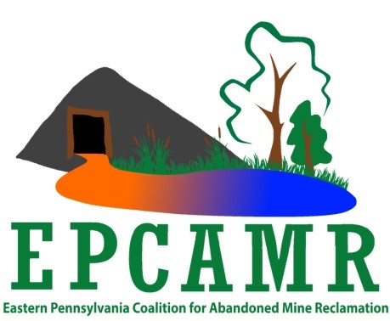
Eastern PA Coalition for Abandoned Mine Reclamation

Robert E. Hughes
EPCAMR Executive Director
101 South Main Street
Ashley, PA 18706
Phone: (570) 371-3523
rhughes@epcamr.org
Website: www.epcamr.org

February 25, 2019

The Honorable Governor Wolf
Office of the Governor
225 Capitol Building
Harrisburg, PA 17120

The Eastern PA Coalition for Abandoned Mine Reclamation (EPCAMR) opposes your budget proposal to strip tens of millions of dollars away from tangible project investments in order to fund general government operations.

It’s been suggested that money can be taken from the Keystone Recreation, Park and Conservation Fund (Keystone) and the Environmental Stewardship Fund (ESF) because no harm will be done to project investments, and the proposed budget action would only tap unneeded money that’s just sitting around.

This imprudent notion misses fundamental issues:

Keystone and ESF were established to fund projects that make lasting improvements in communities; redirecting their funds to support government operations would seriously damage the reliability of these workhorses for achieving community and environmental improvements across the Commonwealth.

Keystone and ESF are starving for funds. Even without this budget proposal, they can’t meet the demands for project investments or the needs driving the demands (as described in the sections below)—not even close.

The Keystone and ESF monies in state accounts are committed to projects; capital projects by their nature can take a few years to complete. If the state were to redirect any of these committed monies into operations, the state would in fact be un-committing to the projects. Under future budgets, the state could recommit funds to those projects, but, in the meantime, communities would be placed in the difficult position of making major expenditures with hopes but no guarantees that the state will come through with money in the end. (Note: If Harrisburg decides communities must take on this risk, the monies to be freed of commitment should at least be redirected to funding the large backlog of unfunded and underfunded Keystone and ESF projects.)

Helping Communities Help Themselves; Leveraging Private and Local Resources
The Keystone Recreation, Park and Conservation Fund and Environmental Stewardship Fund owe their success and longevity to their direct support of community-driven projects. The dedicated funds empower local people and the private sector to address problems at their source, not from afar in Harrisburg. Every dollar in state grants typically leverages at least $1 in other investments and usually the multiplier is much larger. The Keystone Fund alone has leveraged more than $1 billion in public/private partnerships to complete nearly 5,000 projects.

Unmet Demand
Keystone and ESF come nowhere near to meeting present demand. Roughly half of all project investment proposals must be turned away. In the case of DCNR Keystone investments, 46% of projects are rejected for lack of sufficient state funds. And these rejections only represent a portion of unmet demand because grant applicants greatly self-limit their submissions knowing that competition for scarce dollars is fierce. Further, even for those projects funded, DCNR is only able to fund 85% on average of each request (and those requests already are generally limited to 50% of total project costs).

The Need
Pennsylvania’s environmental funding needs are huge. Pressing water issues—from water quality investments needed for the Susquehanna and Chesapeake and Pennsylvania’s other water basins to municipal stormwater management and flood reduction measures—hundreds of millions if not billions of dollars are needed in the coming years. The proposed budget diversion would worsen the needs as it would effectively take money away from communities as they work to address stormwater, flooding, water treatment, abandoned mine drainage remediation, abandoned mine land reclamation, and other environmental issues.

The Keystone Fund delivers $7 in flood control and prevention, water treatment, and other natural services for every dollar invested. (See Pennsylvania’s Return on Investment in the Keystone Recreation, Park and Conservation Fund and other studies in the Economic Benefits section of https://conservationtools.org.) Now is the time to strengthen Pennsylvania’s dedicated environmental funds, so that they can deliver more, not less, in project investments.

Looking beyond water issues, our parks, trails, and other outdoor recreational spaces all have pressing needs. A new report identifies a billion dollars in deferred maintenance in our state parks and forests. (See https://paparksandforests.org/initiatives/infrastructurestudy/.)

Workhorses for Lasting Improvements
The Keystone Recreation, Park and Conservation Fund and Environmental Stewardship Fund are the state’s workhorses for investing in projects that bring lasting benefits to communities across the Commonwealth. Among their many accomplishments, they've effectively and efficiently improved water quality, conserved lands important to local communities, and created outdoor recreation opportunities for visitors and tourists alike. Their exemplary track records and the needs they address are described at length at https://KeystoneFund.org and https://GrowingGreener.info.

Operations Should Be Funded Through General Fund
EPCAMR respects that PA DCNR and PA DEP need money to operate and that environmental staffing has plummeted in the new millennium. However, the answer to agency needs lays with the General Fund—the appropriate source for general government operations—not in special funds dedicated to investing in projects and to leveraging the incredible energy and resources existing in our communities.

Conclusion
A portion of the realty transfer tax was dedicated to the Keystone Recreation, Park and Conservation Fund in 1993 and landfill tipping fees were enacted to fund the Environmental Stewardship Fund in 1999 (and expanded in 2002) in order to reinvest in our communities, redress the environmental damage of the past, and respect our generations yet to come. Both funds were established with extraordinary bipartisan support in the General Assembly as well as in public referenda. The public’s enthusiasm continues to be overwhelming: 75% of Republican voters, 82% of Democrats, and 87% of independents support taxing themselves more to expand conservation funding. (See survey results at https://conservationtools.org/conservation-benefits/205.)

The Governor’s budget proposal threatens to upend decades of bipartisan consensus on the need to maintain the dedication of the Keystone Fund and ESF so that they may consistently invest in projects that deliver today and will continue delivering for future generations.

EPCAMR asks the Governor to rethink the Administration’s strategy and for the General Assembly to reject this proposal. EPCAMR is a partner of the Growing Greener Coalition. We are ready and willing to meet with your Team, and legislators to resolve the gaping disconnect between the budget proposal. We understand the reality of the gross shortages in available project funding.

Your RESTORE PA initiative is a positive step in the right direction. EPCAMR supports your severance tax. EPCAMR has been working in underserved communities on abandoned mine reclamation, abandoned mine drainage (AMD) remediation, flooding prevention, stormwater management, sediment reduction projects, watershed restoration, economic development of blighted abandoned mine lands, infrastructure improvement projects, riparian corridor restoration, trout stream restoration and protection, and innovative approaches to understanding underground mine pools throughout the coalfields of PA.

Respectfully submitted,

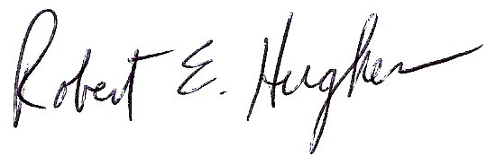

Robert E. Hughes
EPCAMR Executive Director

